Oracle Server都裝好了,DTS怎麼設定DB.
- setup Oracle client
- set net manager of client.
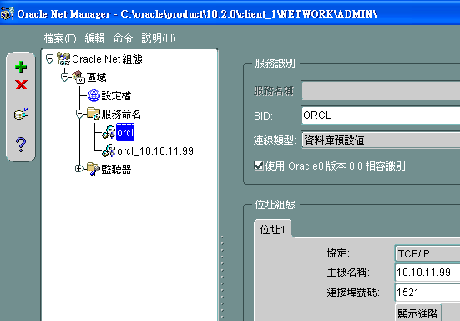

- set dts db.
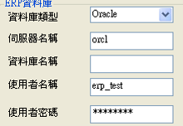 erp_test/erp_test@orcl

